Chapter 13, Problem 73.

Figure 13.134 below shows a three-phase transformer that supplies a Y-connected load.

(a) Identify the transformer connection.

(b) Calculate currents I₂ and I_{c}.

(c) Find the average power absorbed by the load.
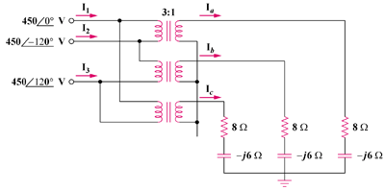

Figure 13.134
For Prob. 13.73.

